5. ReactJS-HOL.docx:
Downloaded and extracted the zip and from the command prompt installed the node modules using “npm install” command.
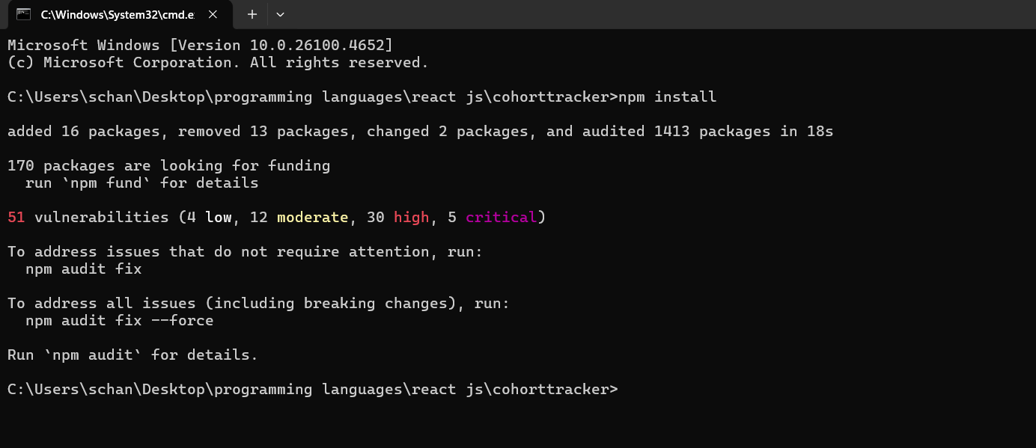
I have already installed the node modules previously that’s why it is not showing the installation process.
Create module.css in the sec directory
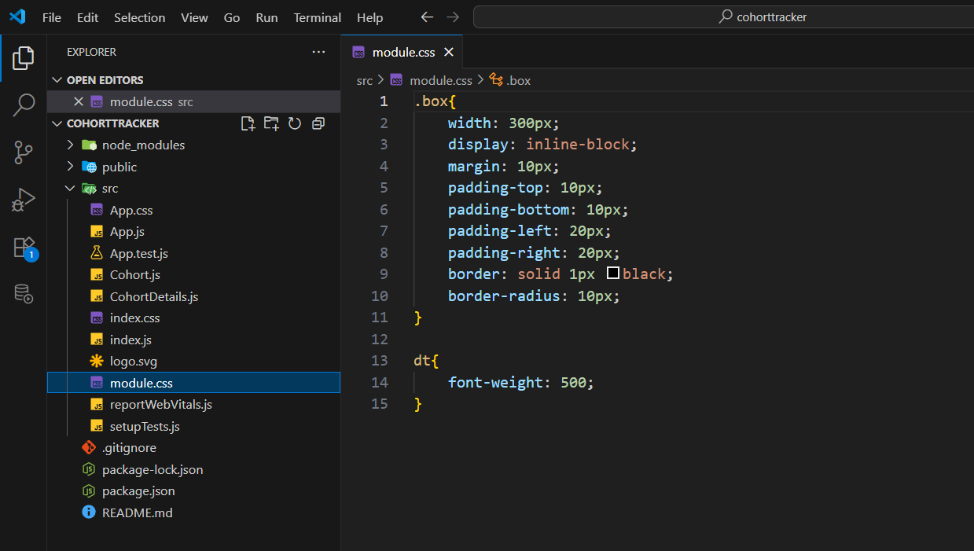
Add this file in the CohortDetails file to apply styles.
Also include a colour of the heading tag based on the status.
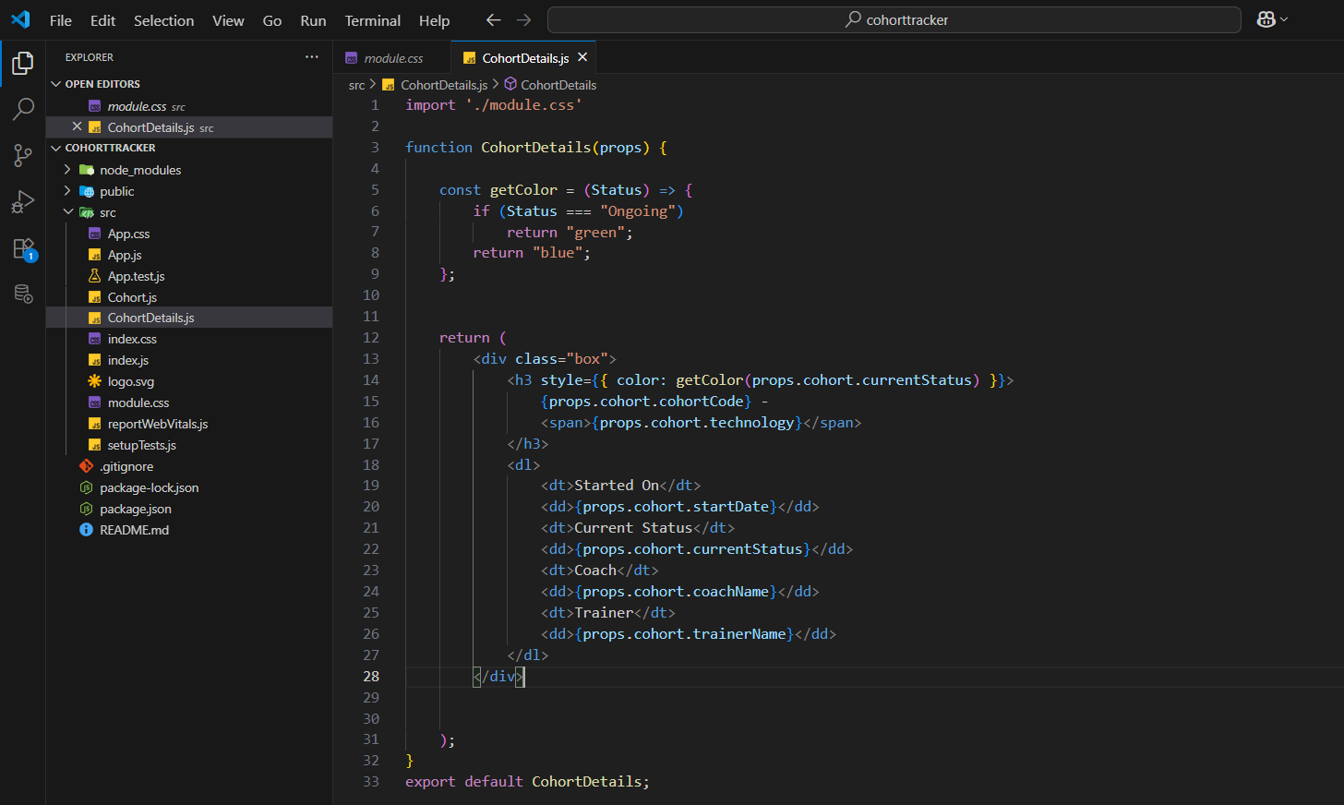
Output:
